In this section we're going to build something which is called a reflexion agent. It's going to extend our previous example of the reflection agent, but it's going to incorporate tools, for example, a search tool which is going to search online for real time data to enrich our answer.
And we're going to review some advanced prompt engineering techniques in order for our reflection agent to be able to digest the feedback correctly and to really address and improve through the iterations, because to create a critique, it's not that hard, but to really leverage the LLM to incorporate that critique and to improve over time is something which is challenging.
https://arxiv.org/pdf/2303.11366
This project demonstrates advanced AI agent capabilities using LangGraph's state-of-the-art control flow mechanisms for self-reflection and response refinement.
The goal of the reflexion agent is to give us a very detailed article about a topic that we will give it, and we want the article to dynamically fetch relevant information from the web, and we want to have citations for the reference data. And of course we want to incorporate a quality right critique loop. We basically want to get a very high quality answer.
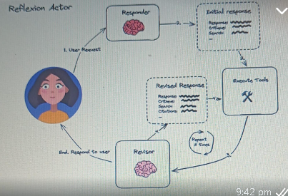
Architecture:
- We first have a responder node which is going to respond the initial response. However, it's not only generates the original response, but it also adds a critique to the response itself and a search term. In the search term, the agent is going to come up with ideal search queries that would be beneficial to get a better response. It's going to help us ground the output that we gave with current events and external data that is available online.
- So, after we have the search queries, we're going to execute the execute tools node, which is going to take our search queries, and simply going to use a search engine to retrieve us results in real time. So I'm going to be using Tavily. That is a search engine which is highly optimized for LLM applications. And we can easily downstream the responses that we get, to the LLM.
- Now, we're going to go to the Revisor node. And the Revisor node is going to take the initial response, which has already an initial critique,
and the results of the search engine execution (So it has also external data. It is very relevant to the topic that we're executing.). It's going to take the suggestion that we got in the previous step and articulate a better answer. But not only that, the Reviser is also going to supply us a new critique to the new revision of the article (article response of LLM regarding that topic), and it's going to provide us new search terms that we want to now look up, according to the new revised articles that are going to be beneficial, and it's going to give us citations of the first search that we had.
- And after that, we're going to continue and search for the new queries. We're going to downstream the new information alongside with the critique, and we're going to revise it again. So, this loop is going to keep happening until we hit a stopping condition. And after that we finished.

